Stage 2 Physics

Electricity Practical Assessment

Name:

Score: /20

**Determining the relationship between potential**

**difference and current in a resistor**

The amount of current flowing in a metallic conductor depends on the amount of charge flowing past a point per unit time.

If you apply a potential difference, V, across the ends of a conductor it will cause a current, I, to flow. You can use a voltmeter to measure the electrical potential difference, V, between the ends of a metal wire resistor and you can measure the current, I, in that resistor with an ammeter.

In this experiment you will investigate the relationship between current and potential difference to determine if an electrical device is ohmic or non-ohmic and to determine the resistance of a resistor.

Equipment:

Power supply (0 – 12 V)

Electrical leads × 6

Single globe (12 V)

Voltmeter (0 – 12 V)

Ammeter (0 – 5 A)

Switch

Unknown Resistor × 1

Procedure:

1. Before connecting the circuit use the voltmeter measure the terminal voltage of the power supply without an load. Record this value in the column headed “Terminal Voltage” in table 1 below (Repeat for each voltage).  
   [Terminal Voltage is the voltage provided by the Power supply and is not always the same as the dial suggests, so needs to be measured for each setting]
2. Connect the equipment as shown in the circuit diagram below.  
   **Note your resistor number in the space at the top of the next page.**

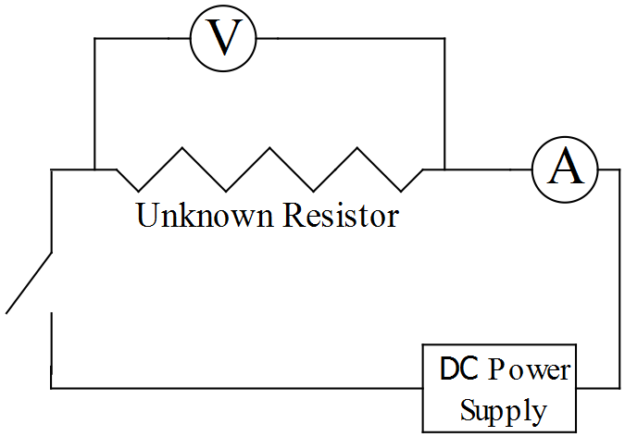

1. Set the power supply to the minimum output.
2. Set both meters to the maximum reading (i.e. 5 A or 12 V) before turning on the power supply and check for correct polarity. With the meters working correctly continue with the lab test.
3. Adjust the power supply output to get five different readings of potential difference and current, recording results in the table below.  
   (Note: **do not run the circuit for more than 10 – 15 seconds.** If the current is too high in may overheat the resistor, damaging it.)
4. Repeat steps 5 & 6, replacing the unknown resistor with the 12 V globe. Record your results in Table 2

Processing Results: Resistor Number:

1. Record you results for the unknown resistor. Calculate and record values for . (2)

|  |  |  |  |  |
| --- | --- | --- | --- | --- |
| Table 1: Results for unknown resistor | | | | |
| Reading | Terminal Voltage | Current (A) | Potential Difference (V) |  |
| 1 |  |  |  |  |
| 2 |  |  |  |  |
| 3 |  |  |  |  |
| 4 |  |  |  |  |
| 5 |  |  |  |  |

1. Record your results for the 12 V globe. Calculate and record values for . (2)

|  |  |  |  |  |
| --- | --- | --- | --- | --- |
| Table 2: Results for 12 V globe | | | | |
| Reading | Terminal Voltage | Current (A) | Potential Difference (V) |  |
| 1 |  |  |  |  |
| 2 |  |  |  |  |
| 3 |  |  |  |  |
| 4 |  |  |  |  |
| 5 |  |  |  |  |

1. Plot the graph of potential difference, V, against current, I (i.e. current on the horizontal axis) for the unknown Resistor and the 12 V globe. (4)



Questions:

1. State which component (if any) was ohmic or non-ohmic.
   1. Unknown Resistor: Ohmic (1)
   2. 12 V globe: non-ohmic (1)
2. Using the graph for the Unknown Resistor:
   1. On the graph show two points which could be used to determine the slope of this graph (1)
   2. Calculate the slope of the graph (show working). (2)
3. Briefly state the relationship between slope and resistance exhibited on your graph. (1)

The slope of the graph is equal to the resistance

1. State the value of the unknown resistor according to your graph. (1)

Unknown Resistor =

1. A metal wire used as a resistor will typically be ohmic for a given range of applied potential difference, but not at higher voltages. Explain what happens to their resistance characteristics at these higher voltages and why. (3)

The higher the voltage, the greater the current.

The high current increases the temperature of the wire.

The increase in temperature causes the resistance to increase.

1. What is the resistance of an ideal ammeter and why? (2)

The ideal resistance of an ammeter is 0 ohms so as to have no effect on current.